**INSTALLATION GUIDE**

1. This is an installation guide to Photography Website Project. The theme of my project was to create a website for Online Photography Store. Mostly it well well, but I had some difficulty in writing orders to database, also with other things (applying coupon discount at payment/checkout stage, and being able to remove items placed in shopping cart).
2. The Structure of my Photography Online Store is as follows:-

3) The Structure of my website is as follows (see screenshot below):-

(*Please note ‘**module_website.html** is the main page for running and uploading all other web pages. SQL database can be replicated by using the same name (**Web_Apps**) which I used to create this database. I have also included (as per screenshot below) SQL files for this project. The name of the database is Web_Apps. I have exported this, and should be imported.

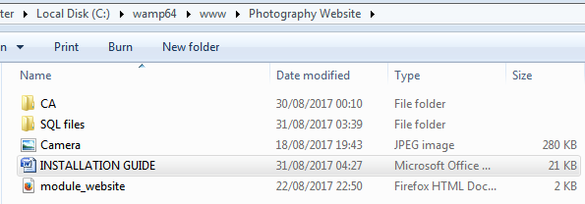

With the CA folder is contained following folder (Link to Online Photography Store).

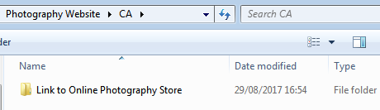

Within the CA Folder is the following folder (Web_App), which contains many folders (as per screenshot below).

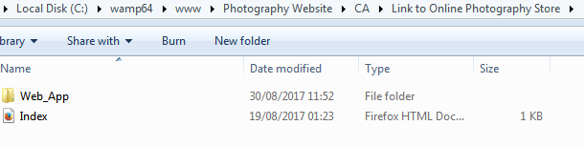

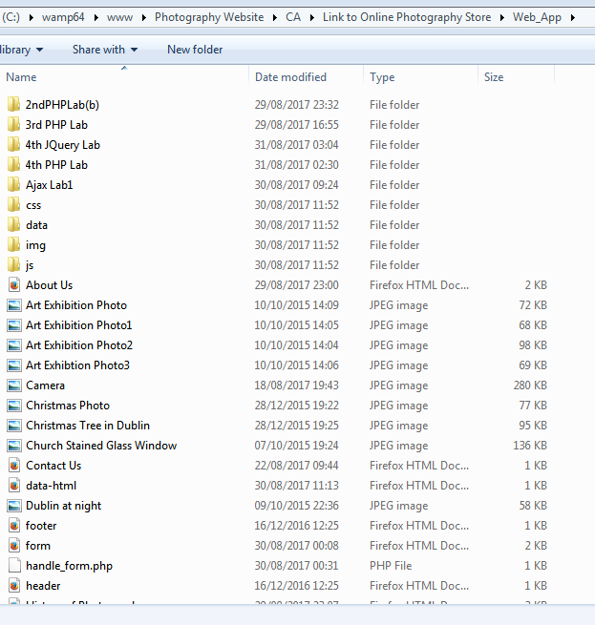

1. I encountered an error in writing orders to database. I am unsure (at present!) how to resolve this issue, but hoped to resolve it. However, I did not manage to sort it out before submitting the project. Hence there were no orders placed in database. Please see screenshot below and screenshot of message I get when I try to place an order. It appears that the order has gone through but it doesn’t show on database! I will work on finding a solution to this.



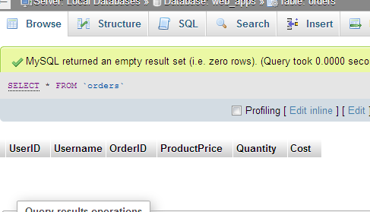

1. Requirements for deploying my project are:-
2. You either have WAMP server on your computer or you install it.
3. Then create a database **Web_Apps** and copy SQL files (with users and orders database).